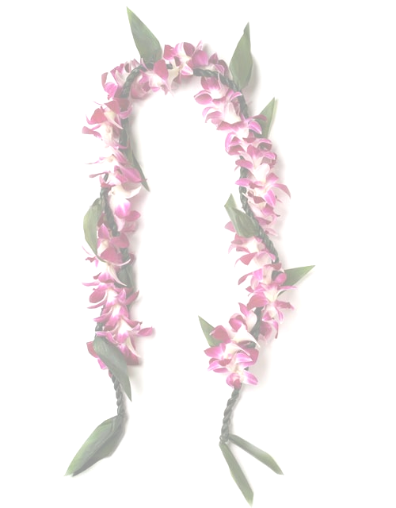
Halau Kalama
1732 S Chambers Rd
Aurora, CO 80017

To Whom It May Concern,
We are Halau Kalama, a Polynesian cultural organization in Aurora, Colorado. We are a non-profit organization with a mission to educate and promote the art of Polynesian music, language and dance to all. Together, members of Halau Kalama collaborate and strive to entertain as well as enlighten all communities who wish to experience the “Aloha Spirit.” Back in 2007, we started with only 3 members and now we have 80+ and still growing, ranging from ages as young as 3 to over 50 years old.
With many performances throughout the state of Colorado, our 13th Annual Lei Day Festival will take place on Saturday, June 13, 2020. Lei Day is a day we celebrate and embrace our island culture. It's a day of color, celebration, flowers and aloha! With that in mind, every year since 2007 Halau Kalama has been celebrating Lei Day in Denver to share not only the Hawaiian culture, but all cultures of Polynesia – from Tahiti to New Zealand and Samoa!
As a non-profit organization 501(c)(3), Halau Kalama provides discounted dance instruction to those who wish to learn and embrace the Polynesian culture. We also volunteer performing at various community events and retirement homes/assisted living facilities, as well as for other non-profit organizations such as The Ronald McDonald Home & Food Bank of The Rockies. Additionally, Halau Kalama offers an ‘Ohana Kokua Program (‘Ohana meaning ‘Family’ and Kokua meaning ‘Help’) for those who are in need of any type of assistance (e.g. financial, food, etc.).
The funds raised or received from donations help to offset the cost of our dance studio, and the costs of hula implements/musical instruments, as wells as, materials and supplies used to create costumes for our students to wear at our various performances (e.g. Colorado Dragon Boat Festival, Boulder Aloha Festival, Guam Liberation, Rocky Mountain Airshow, etc.).
We graciously accept any type of donation to help carry out our mission and are very appreciative and humbled by your generosity. We are a tax-exempt U.S. charitable organization granted 501(c) (3) status by the Internal Revenue Service. All donations are tax deductible. Monetary Donations can be sent directly to our Studio at:
Halau Kalama
c/o Ellen Akiona
1732 S Chambers Rdt
Aurora Co 80017

Mahalo nui loa,
Ellen Akiona (303-520-6393) Federal Tax ID: 45-3170062
2020 Lei Day Chairperson--

We are seeking corporate sponsorships. If your company would like to become a Corporate Sponsor please select the sponsorship level desired:
(Please make checks payable to Halau Kalama)

______ Platinum (Kalani) $5000
Companies who donate at the Platinum Level will receive a 60-minute Polynesian Dance Show for your company party or event (a $1200 value and the date and time must be arranged with Halau Kalama at the time of booking, not valid on holidays and must be redeemed by December 31, 2020 and based on availability), Your company name and phone number or web address will be displayed on our Halau T-shirt (worn by Halau members and their families to performances all over Colorado, such as Colorado Dragon Boat Festival, Boulder Asian Festival, Ronald McDonald House, Rocky Mountain Airshow, and other public and private events), a link to your company webpage will be added to our Halau Website for one year, your company will be promoted on our Halau Facebook Page, and your company business card or company information will be included in our Lei Day program. Between 800-1000 Lei Day programs will be distributed. T-shirts may possibly be sold as well at our Lei Day performance to our audience of 800-1000 people, further extending the marketability of your company. Your company will also be written in the Program script as our Proud Sponsor.

______ Diamond (Ali’i) $2500 donation
Companies who donate at the Diamond Level will receive a 25-minute Polynesian Dance Show for your company party or event (a $525 value and the date and time must be arranged with Halau Kalama at the time of booking, not valid on holidays and must be redeemed by December 31, 2020 and based on availability),
Your company name and phone number or web address will be displayed on our Halau T-shirt (worn by Halau members and their families to performances all over Colorado, such as Colorado Dragon Boat Festival, Boulder Asian Festival, Ronald McDonald House, Rocky Mountain Airshow, and other public and private events), a link to your company webpage will be added to our Halau Website for one year, your company will be promoted on our Halau Facebook Page, and your company business card or company business information will be included in our Lei Day program. Between 800-1000 Lei Day programs will be distributed. T-shirts may possibly be sold as well at our Lei Day performance to our audience of 800-1000 people, further extending the marketability of your company.

_____ Gold (Kahuna) $1000 donation
Your company will have a link on our various Halau Websites for one year (or company information posted if you do not have a company webpage), your company will be promoted on our various Halau Facebook Pages, and your company business card or company information will be included in our Lei Day program. Between 800-1000 Lei Day programs will be distributed.

______ Silver (Alaka’i) $500 Donation
Your company will be promoted on our various Halau Facebook Pages, and your company business card or information will be included in our Lei Day program. Between 800-1000 Lei Day programs will be distributed.

If you would like to donate a gift certificate or other product for the Raffle, Give-Away or Silent Auction for Lei Day Show, we will feature your business in our Lei Day program.

Thank you in advance for your support in our mission to share the Aloha Spirit here in Colorado! Should you have questions, please contact us. You may also email us at denverleiday@gmail.com.

Mahalo nui loa (Thank you very much),

Ellen K. Akiona-303-520-6393
2020 Lei Day Coordinator
Halau Kalama
Federal Tax ID: 45-3170062

**Please list “other” donation here:
_______________________________________________________________________________________________________________________________________________________________________________________________________________________________________________________________________________________

2020 Halau Kalama Donation Request Letter

